**18-07-2024 Java Lab Codes**

Program 1:

public class Main

{

public static void main(String[] args)

{

    int myInt=9;

    double myDouble=myInt;

    System.out.println(myInt);

    System.out.println(myDouble);

int sum1=100+50;

    int sum2=sum1+250;

    int sum3=sum2+sum2;

System.out.println(sum1);

    System.out.println(sum2);

    System.out.println(sum3);

}

}

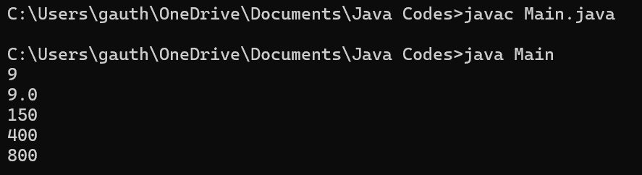

Program 2:

public class Main

{

public static void main(String[] args)

{

    String a="hello";

    int sum4=a+sum3;

    System.out.println(sum4);

}

}

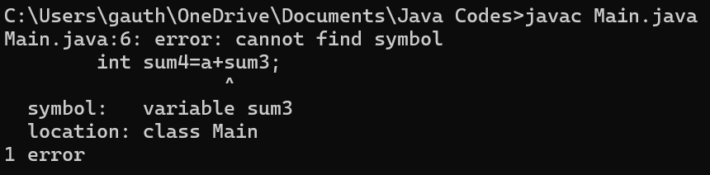

Program 3:

public class Main

{

public static void main(String[] args)

{

    int x,y;

    x=20;

    y=(x==1)?61:90;

    System.out.println("Value of y is: "+ y);

    y=(x==20)?61:90;

    System.out.println("Value of y is: "+y);

}

}

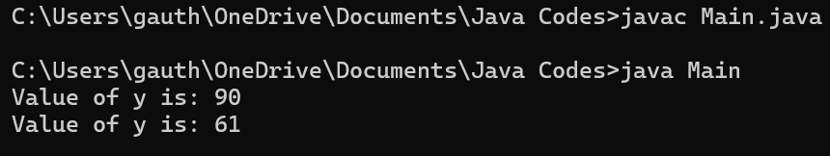

Program 4:

public class Main

{

public static void main(String[] args)

{

    String txt="abcdefghijklmnopqrstuvwxyz";

    System.out.println("The length og the txt string is: "+txt.length());

}

}

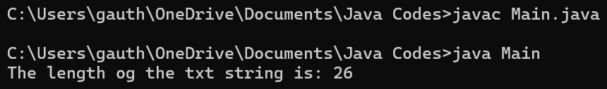

Program 5:

public class Main

{

public static void main(String[] args)

{

    String txt="Hello World";

    System.out.println(txt.toUpperCase());

    System.out.println(txt.toLowerCase());

}

}

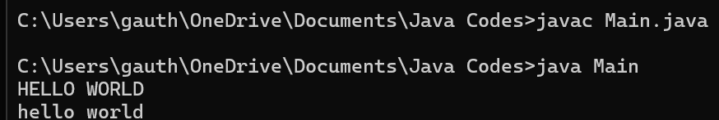

Program 6:

public class Main

{

public static void main(String[] args)

{

    String text="Please locate where 'locate' occurs!";

    System.out.println(text.indexOf("locate"));

}

}

